**Wireless Robot circuit**

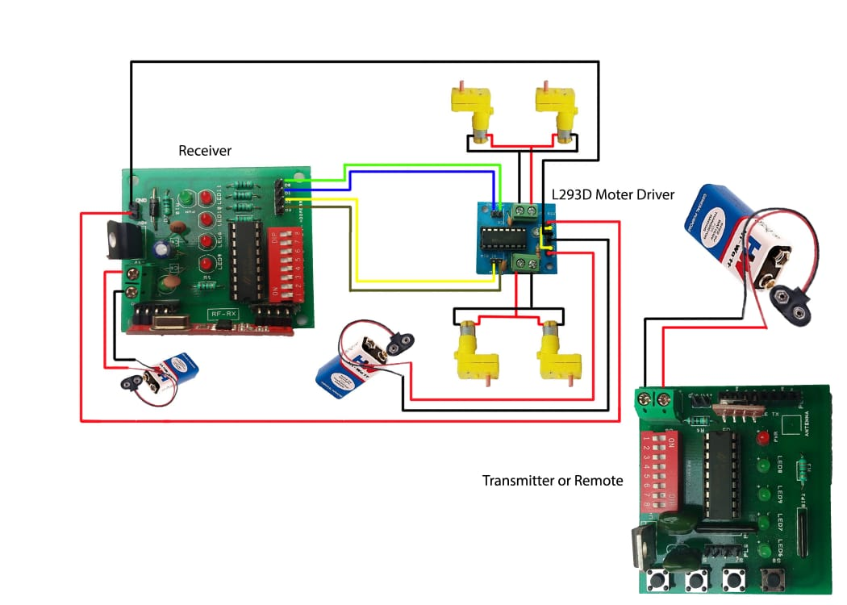

***PART-2 GESTURE CONTROLE ROBOT***

* ***RX CIRCUIT***

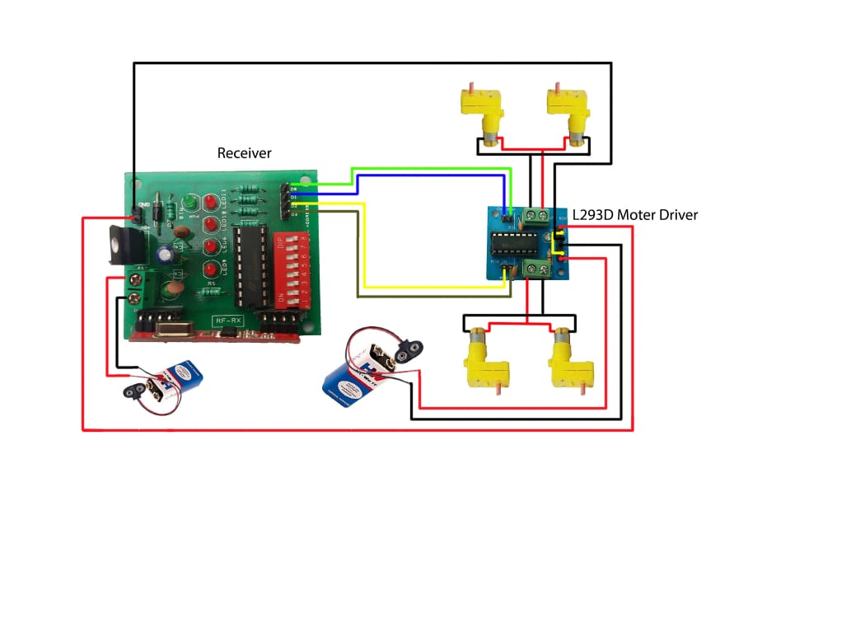

* **TR CIRCUIT**
* 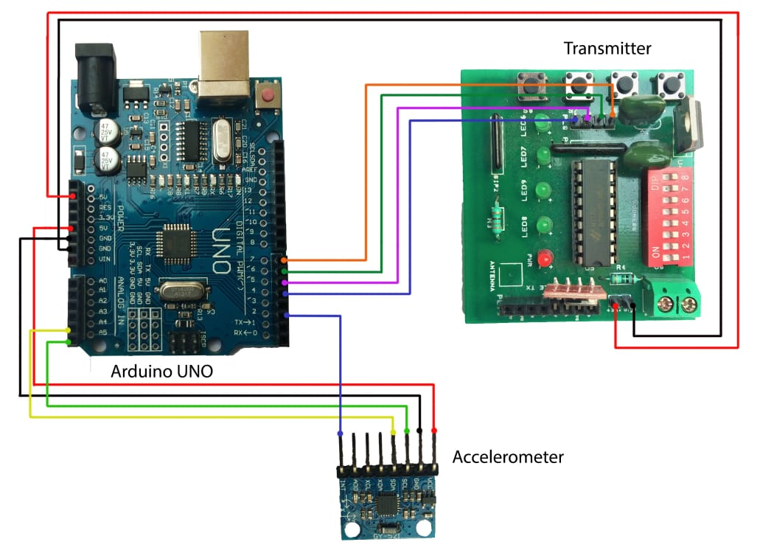

**CODE FOR GESTURE CONTROLE ROBOT**

**#include <MPU6050_tockn.h>**

**#include <Wire.h>**

**MPU6050 mpu6050(Wire);**

**long timer = 0;**

**void setup() {**

**pinMode(4, OUTPUT);**

**pinMode(5, OUTPUT);**

**pinMode(6, OUTPUT);**

**pinMode(7, OUTPUT);**

**Serial.begin(9600);**

**Wire.begin();**

**mpu6050.begin();**

**}**

**void loop() {**

**mpu6050.update();**

**Serial.print("accX : ");Serial.print(mpu6050.getAccX());**

**Serial.print("\taccY : ");Serial.print(mpu6050.getAccY());**

**Serial.print("\taccZ : ");Serial.println(mpu6050.getAccZ());**

**if (mpu6050.getAccX() >= 0.70)**

**{ //FORWARD**

**digitalWrite(4, HIGH);**

**digitalWrite(5, LOW);**

**digitalWrite(6, LOW);**

**digitalWrite(7, HIGH);**

**}**

**else if(mpu6050.getAccX() <= -0.60)**

**{ //BACKWARD**

**digitalWrite(4, LOW);**

**digitalWrite(5, HIGH);**

**digitalWrite(6, HIGH);**

**digitalWrite(7, LOW);**

**}**

**else if(mpu6050.getAccY() >= 0.60)**

**{ //LEFT**

**digitalWrite(4, LOW);**

**digitalWrite(5, HIGH);**

**digitalWrite(6, LOW);**

**digitalWrite(7, HIGH);**

**}**

**else if(mpu6050.getAccY() <= -0.60)**

**{ //RIGHT**

**digitalWrite(4, HIGH);**

**digitalWrite(5, LOW);**

**digitalWrite(6, HIGH);**

**digitalWrite(7, LOW);**

**}**

**else{**

**digitalWrite(4, LOW);**

**digitalWrite(5, LOW);**

**digitalWrite(6, LOW);**

**digitalWrite(7, LOW);**

**}**

**}**